Career Kete, for years 9-10

Learning and career planning

Explore and Compare
teachers guide

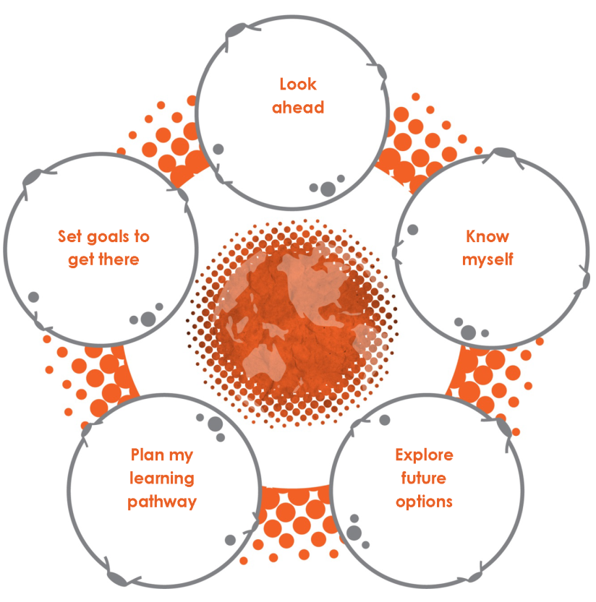

December 2016

This guide is available for download on the
Careers New Zealand website, www.careers.govt.nz
(Use search to locate.)

Copyright

This is a revised version of the Learning and career planning teachers guide, August 2009.

© Careers New Zealand, 2012

Permission is granted to copy and adapt this work in whole or part for career education and guidance purposes within New Zealand. Except as permitted under the Copyright Act 1994 or any copyright licence, no part of this work may be reproduced for other purposes without the prior written permission of the publisher.

Careers New Zealand, PO Box 9446, Wellington, New Zealand
Freephone: 0800 222 733, email: careers@careers.govt.nz, website: www.careers.govt.nz

Acknowledgements

Some of the ideas in this resource have been adapted from the schemes of work provided on the Cegnet website, www.cegnet.co.uk

Table of contents

Career learning and the Career Kete 4

Using Explore and Compare 5

Planning for delivery 6

Learning and career planning 8

Look ahead 10

Know yourself 14

Explore future options 24

Plan my learning pathway 30

Set goals to get there 37

Teacher reference 42

Template letter to parents 43

Activity ideas for developing careers language 45

Using influence scenarios 46

Subject choice checklist 48

Career learning and the Career Kete

The Career Kete teacher guides and student worksheets suggest how young people could learn and develop their career competencies over their time at school.

The three sections in the Career Kete are targeted to three different year levels: years 7-8, years 9-10, years 11-13, but many activities at the lower levels can be used, reused or adapted for reuse with older students.

Select and adapt

Teachers can use the materials in the Career Kete in whatever way is most helpful to their students, adapting them to meet the specific needs and priorities their schools have identified.

When adapting, consider:
- building in cultural, geographical or historical background familiar to students
- providing the right level of challenge for individual students
- adjusting the language to suit your students
- expanding the learning beyond the classroom, eg, guest speakers, web quests
- addressing time, length, coherence and coverage.

Frame and connect

Students will have taken part in a variety of planned and unplanned activities in and out of school that have helped build the foundations for career competencies.

These are activities which have:
- encouraged them to think about who they are and what is important to them
- helped them to see what they can do well and what they want to learn to do better
- developed their ability to relate to and work with others
- introduced them to workplaces and people in those workplaces
- guided them to set goals and monitor their own progress.

Help students build a big picture of this learning.
- Frame and connect the activities in your overall programme, especially if these are spread out over the years
- Make explicit links to what is happening in other parts of students' school experience and in students' out-of-school experiences.

Further information

For more information on learning and career planning and the experiences of schools, read the section on Learning and Career Planning in the handbook Career Education in Practice. This handbook can be downloaded from the Careers New Zealand website, www.careers.govt.nz.

Versions

There are two versions of the student worksheets, in PDF and Word. The Word version is simple to alter. It also makes it possible for students to create electronic copies of their work.

Using Explore and Compare

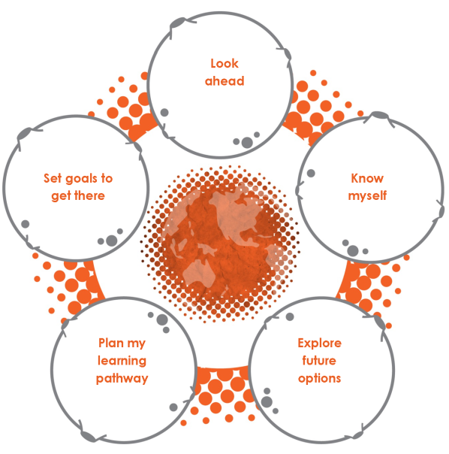
Overview

Explore and Compare is the second section of the Career Kete. It supports students in years 9-10 to make subject choices through a process of learning and career planning.

The content is organised into the five areas:
- Look ahead
- Know myself
- Explore future options
- Plan my learning pathway
- Set goals to get there

Aims of career education in years 9-10

Career Education and Guidance in New Zealand Schools, Ministry of Education, 2009, p15
- "Students build their understanding of their strengths, interests and values and start to consider how these might influence their life, learning and work choices.
- They are developing their confidence as learners, and articulate aspirations and dreams about their future. They understand how they relate to others and the impact their personal decisions have on their lives.
- They learn about senior school courses and how they relate to qualifications. They explore possible career directions without needing to make career-defining decisions.
- They enhance their research skills and increase their awareness of a range of future pathways.

Principles of career education

Careers education and guidance: a scheme of work for key stage 3, 4 and post 16, VT Careers Management, 2003, p4
- young people need encouragement to become career-minded
- positive self-esteem is the key to making progress in learning and work
- individuals need to take responsibility for their own careers
- individuals define career success for themselves
- forging a career is an act of creative self-expression
- ongoing learning is the key to lifelong career development.

Planning for delivery

Choosing activities

This guide suggests a range of activities that can be used for learning and career planning in year 9 to 10. These activities are designed to help students make better subject choices.
- You can pick and choose from the suggested activities in this guide, adapt them, add in others, or change the starting point or sequence in any way that fits your student’s needs and interests and the time you have for this process.
- The activities are designed for students in year 10 but you can select some to adapt and use with students at other levels. For example, some self-awareness activities could begin in year 9 and be reviewed in year 10.
- The Real Game is an effective way to develop students' understanding of the world of work and prepare and motivate them for the activities in Explore and Compare.

Required resources

The resources you need are:
- Explore and Compare student worksheets
- Learning and career plans for students – see below
- access to the Careers New Zealand website, www.careers.govt.nz
- your school’s subject choice booklet.

Depending on the activities you chose, you may also use:
- Jobs Galore (a class set is useful)
- worksheets and activities from other sections of the Career Kete
- other career resources from Careers New Zealand or other providers
- other resources such as magazines and newspapers.

Plan documents

Students enter information into a learning and career plan, or similar document, at relevant points in the process. Many schools develop their own planning document for students.

A downloadable template is available on the Careers New Zealand website www.careers.govt.nz.
- You can freely copy and adapt the template to create plan documents for your students.
- The template is designed as four A4 pages. To print as a booklet, choose the options A3 paper size and booklet print layout on your printer.
- The template is designed as a Word form. If you want students to have an electronic record of their plan, you can ask all students to make a copy of the file. Students can then type their information into their copy using the tab key to move from field to field. To alter the template, select the Forms toolbar and turn off protection (the lock icon).

Preparation and follow up

You are likely to need to involve a range of teachers to deliver learning and career planning.
- Start by agreeing on who will assist with delivery and form an implementation team. Then review this guide as a team to decide what to deliver, when and how.
- Each person may have ideas for other activities that can be used instead of or in addition to the ones suggested in this guide. They may also suggest opportunities in regular classrooms where some of the activities could be introduced.

Preparations for implementation may include:
- presenting information about the process at level assemblies
- writing unit and lesson plans
- developing sets of the resources needed
- providing training to teachers prior to delivery.
  - Include role-modelling of questioning processes that will get students thinking along the right lines in the training you organise.

The time it takes to complete the process depends upon the ability of the individual students, the career education programme they have participated in previously and the way you choose to implement learning and career planning in your school.
- Most stages of the learning and career planning process can be delivered in a class but the concluding interview and review is best done, where possible, one-to-one.
- It is important to consider whether some students may respond better to working in a small group or to receiving individual support on some or most aspects of the process, for example students who may be shy of sharing their goals or those who are easily distracted or struggle in a group environment.
- To complete a full programme of activities could take six to eight hours, including 10-15 minutes to review the outcomes of the planning process with individual students.

Learning and career planning should be followed up in later months and years, at relevant times and in relevant curriculum areas, with discussion and activities where students can reflect on and review their understanding of themselves and their plans.

Engaging students, family and whānau

Students will benefit if you involve their parents/whānau in this process.
- You could encourage involvement by sending information home about what their child is doing and scheduling activities to coincide with career events or evenings for parents and students.
- As a minimum, you should plan to give parents/whānau the opportunity to see and comment on the completed planning, for example, by attaching a copy to the subject choice material that goes home with students for completion, or by letting parents know that they can read it and discuss it at the next parents report evening.

There is a template letter to parents in this guide which you can use as a basis to create your own letter or news item for parents/whānau to help them understand what learning and career planning involves and how they can help their children.

Learning and career planning

Learning and career planning is a process of exploration and discussion that leads to the identification of possible future learning, career and personal goals (in and outside of school).

The aim of the process is to continue to develop the career management competencies students will need to make career-related decisions at school and beyond.

Learning goals

At year 10, learning and career planning is about developing awareness and exploring possibilities, not about students deciding their future.

Students will:
- understand how learning and career planning fits into their lifelong career development
- understand the purpose and process of learning and career planning
- understand the competencies involved in career planning
- develop skills in exploring and researching careers of interest
- understand how other people and external factors may influence their decisions
- develop skills in planning
- understand what they need to do next in order to continue the process.

The process

Students should be introduced to, or revisit, learning and career planning at a point when they are about to make a career decision, typically as preparation for subject choice and transition.

The process involves:
- bridging to prior learning and previous planning activities
- reassessing personal qualities, strengths and goals
- further developing skills to use information about careers, study, training and work
- developing skills to make decisions that affect them personally, to set goals and plan
- reviewing their individual planning process and outcomes.

The three aspects of career management

Know yourself
- Students learn that being able to identify their personal characteristics is an important skill for making life, career, learning or work choices.

Explore opportunities
- Students begin to understand that developing a career direction is an ongoing process that requires good thought and preparation.

Decide and act
- Students appreciate that making decisions involves uncertainty and they should expect to review and remake their plans throughout their lives.

Underlying concepts

At year 10, students are strengthening their emerging adult identity.
- They are at the stage of believing that they can have a career and pursuing realistically high aspirations.
- They need opportunities to develop the skills that will help them manage their experiences of learning and work.
- They believe they have plenty of time to make decisions about a career. They are looking for:
  - information on the qualifications required for a range of jobs
  - advice and encouragement to investigate career options open to them
  - assistance with subject choice
  - opportunities to build their knowledge of work and workplaces.

Career planning is a process of exploration and discussion that leads to the identification of possible future options and goals.
- It needs to be ongoing and personalised so that students can review and reflect on their ideas as their understanding of themselves and of work evolve and develop
- It supports students to make personal decisions about the future.

Important points
- Some students will be uncomfortable with the idea of identifying their strengths because they feel it might be showing off. This can be a developmental issue, fear of being a ‘tall poppy’ or cultural. Students need to be supported through this discomfort and brought to understand that being able to identify your own areas of strength is an essential skill.
- By the time your students enter the workplace the jobs they explore now are likely to have changed in many ways. Students need to be made aware constantly of the need for flexibility and adaptability.
- It is important that students appreciate that they will change a great deal over the coming few years and so they need to make choices that don’t shut out options for them later on. They also need to know it is OK to change their minds about what they choose now.
- Some students and parents will get hung up on making ‘the right choice’. Part of the message to them needs to be that there are all sorts of ways to get to what you want to do and that students will need to remake their plans at various stages of their lives.

Plan template pages 1, 4, 2, 3
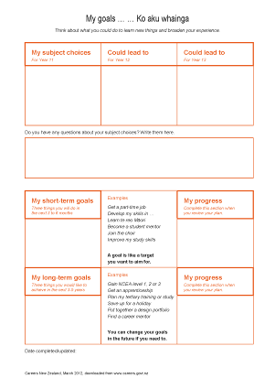
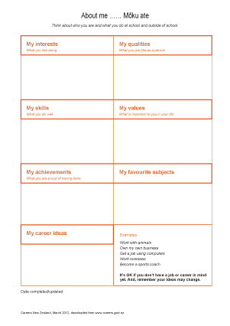
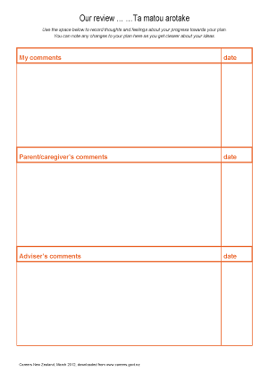

Look ahead

About this section

Introduces the purpose and process of learning and career planning and starts students thinking about directions they may take in life.

Prior learning

Students in year 9 may not have a clear recollection of activities that contributed to career education in their primary years. Most will have assessed their key competencies and explored different jobs or workplaces in their community. Many will not have related what they observed and learned to the concept of a career.

Learning outcomes
Career learning outcomes | Key competencies
Develop understanding of the need for positive attitudes towards learning and work  Demonstrate understanding of short- and long-term career planning | managing self  thinking

Student worksheets used in this section

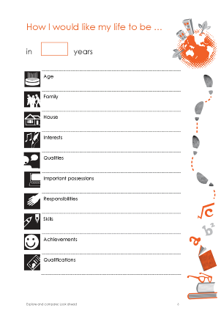
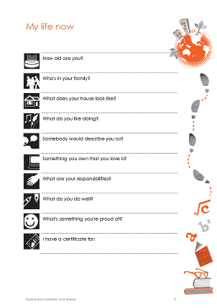
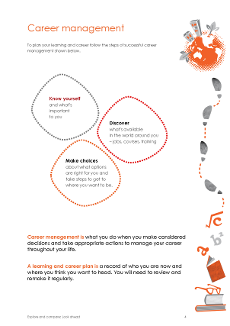
Possible futures

Key messages
- Learning and career planning starts you thinking about who you are and what you want in life, career and work.
- It's about developing self-awareness and exploring possibilities, not about deciding your future.
- It will help you select subjects for next year and beyond.
- It will help the school understand and help you to achieve your goals.
Possible activities | Possible resources
- Review students' perceptions of what a career is. Explore the relationships between the term and other words like learning, work, profession, employment, job, trade, entrepreneur, full-time parenting, etc. | - Jobs Galore, pg 1-2,  What is a career?
- Explain to students how learning and career planning fits in with their lifelong career management. Introduce the three aspects to career management: Know yourself, Explore opportunities, Decide and act. | - Explore and compare, pg 3, Career management is …
- Discuss how we all need to have a picture of where we would like to be when we start planning anything. Invite students to create a simple picture of what they would like their lives to be at a future time. | - Explore and compare, pg 3-4,  My Life now; How I would like my life to be in …

Know yourself

About this section

Reviews students' understanding of themselves and helps them connect skill development to subjects.

Prior learning

Many year 9 and 10 students will have taken part in planned and unplanned activities that have helped develop their understanding of their key competencies, personal qualities, abilities and strengths. Students will be less familiar with skills and work values.

Learning outcomes
Career learning outcomes | Key competencies
Demonstrate knowledge and understanding of their qualities, skills, values and career interests.  Demonstrate an awareness of things that could help or hinder the development of their capabilities and career interests. | managing self  thinking

Student worksheets used in this section

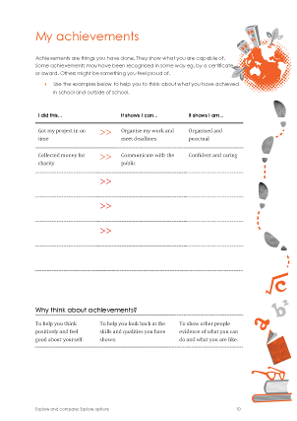
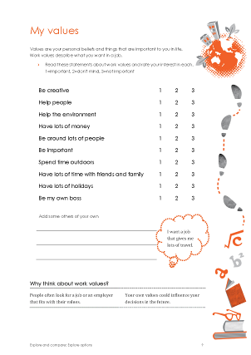
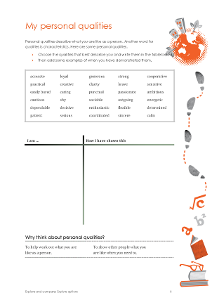
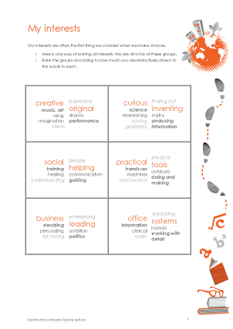
Student worksheets used in this section (continued)
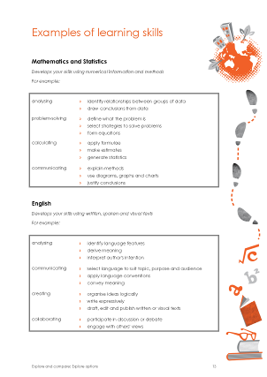
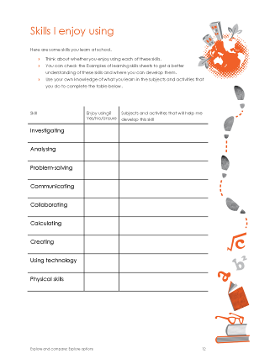
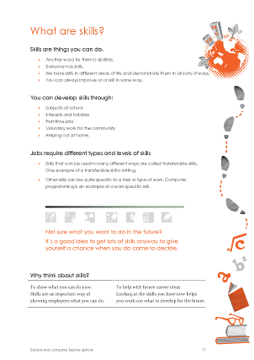

There are four other Examples of learning skills worksheets that follow this page.

Setting the scene

Key messages
- If you are going to make decisions that are right for you, then you need to think about all the things that make you 'you': what you enjoy, what you are good at, what's important to you, etc.
Possible activities | Possible resources
- Ask students about times in the past when they have been encouraged to think about themselves: about what they like, what they are good at, skills they want to develop, etc.
- Discuss what it means to 'know yourself' and why it is important in career decisions. | - Jobs Galore, pg4,  Know yourself
- Use stories of colleagues, yourself, or people you know to illustrate how ‘knowing yourself’ led on to fields of training, etc.
- Brainstorm questions that people ask to find out what others are like.

Students identify their interests

Key messages
- Your interests are the things you enjoy doing. People enjoy their work more if they are doing something they are interested in.
- Your interests now may not be your interests later. You may develop new interests or come to realise you enjoy things you didn't think you would.
Possible activities | Possible resources
- Students brainstorm things that they enjoy doing at home, at school, at work and in the community. Examples:
  - watching law dramas
  - experimenting with recipes
  - wondering how machines work.
- If students begin with general ideas, eg, ‘watching TV’, use questions to elicit more detail, eg, ‘What kind of TV do you like watching?’
- In groups or as a class students think of ways they could group the things they enjoy and name these groups. Discuss how grouping things can help us see the similarities and differences between them.
- Students look at one way of categorising interests and order the groupings to reflect their individual interests. | - Explore and Compare, pg 7,  My interests
- Each student identifies the things they do that interest them most and writes these in the My Interests section of their learning and career plan.
- Look for students who find it difficult to choose a few top interests and work with them to refine or group their ideas

Students identify their personal qualities

Key messages
- Personal qualities describe what you are like as a person, eg, I am hard working, my friend is generous.
- Employers look for people with the personal qualities that suit the job. When you apply for a job, you need to highlight how you meet their requirements.
Possible activities | Possible resources
- Use an activity of your choice to check students understand words that are commonly used to describe a person's qualities. | - In this guide: Activity ideas for developing careers language
- If you have students who are likely to feel uncomfortable deciding what qualities they have, you might want to try a group activity where they describe someone else in the group before going on to think about themselves.
- Students look at a list of personal qualities and think about which words describe them. | - Explore and Compare, pg 8,  My Personal Qualities  - Suitable career stories or profiles
- (optional) Students create a poster to illustrate their personal qualities.
- Each student writes their qualities in their learning and career plan.
- (extension) Students look at job vacancy advertisements and identify the personal requirements in each and how frequently they occur. | - Job vacancy ads from papers and websites

Students identify their developing skills

Key messages
- Skills are things you have learned how to do well. Some are easy to see, eg, I can use a video camera; some are not, eg, I can solve problems.
- You learn lots of skills in your everyday activities at school and out of school.
- Employers look for people with the skills needed to do the job OR the ability to develop those skills. When you apply for a job, you need to be able to show you have demonstrated these skills or how you can develop them.
Possible activities | Possible resources
- Students in pairs think of an activity that they enjoy doing and explain to their partner what they would need to do to get better at this activity.  - Ask some pairs to share their discussions with the rest of the class and lead a discussion on the part played by skills in being good at an activity. Remind pupils that personal qualities are also important. | - [teacher reference] Understanding career education in years 7 and 8,  pg 8-9, Engaging students by using their own lives to teach them about skills
- Ask students to suggest places and ways they learn skills. | - Explore and Compare, pg 11, Skills
- Students may not be familiar with the language of skills. It is worth spending some time on developing their understanding of common skill terms.
- Students look at a list of transferable skills they are developing at school and work out which they enjoy and what subjects can help them to develop them. | - Explore and Compare, pg 12, Skills I enjoy using, pg 13-16, Skills at school
- Each student writes their most enjoyed skills in the My Skills section of their learning and career plan.
- (extension) In groups students look at a number of Kiwi Cards and decide which of the skills they are learning in their subjects will be useful to the kiwi in the job they think s/he is doing. | - Kiwi Cards (downloadable pages or the cards themselves if you have them)

Students identify their values

Key messages
- Values are the things you believe in and the things that are important to you. They shape the way you want to live your life.
- You need to think about how your values will fit with any job or workplace you are considering. If they do fit, you are more likely to enjoy your work and your life outside work.
Possible activities | Possible resources
- Give students a couple of examples of values, eg, fairness, and ask them to explain what values are and to suggest some others they can think of.
- Choose a couple of the values suggested and explain how these relate to work decisions.
- Introduce the idea that there are values people have specifically about the kind of work they want to do.  - Give students a couple of examples of work values, eg, be part of a team, and ask them to brainstorm what they think some others might be.  - Ask each student to look at a list of values and decide how important each one might be to them when they are thinking about different jobs. | - Explore and Compare, pg 9, My values  - [teacher reference] The Real Game, facilitator’s guide,  pg 82, Looking back, Thinking ahead
- Developing a set of values is a developmental task of adolescence. Students may vary in their level of maturity. Early values might be fun, excitement, lots of money; later values might be helping others.
- Each student writes the things that are most important to them in the My Values section of their learning and career plan.
- (extension) Give groups a description of a job that they would be somewhat familiar with, eg, TV presenter, truck driver. Ask them to choose the work values on the list that people in that job might share. | - Careers New Zealand website, jobs database  - The Real Game, role profiles

Students identify their achievements

Key messages
- Achievements are successes that you feel satisfied about or proud of. They can be big or small.
- Some achievements are recognised – with an award for example; many go unnoticed.
- Achievements give us confidence in ourselves and in our ability to reach our goals.
- Your achievements can show others what you can do and what you are like.
Possible activities | Possible resources
- Talk to students about the different contexts in which they achieve, and elicit some examples from them:
  - classroom activities, eg, finally understanding some maths you were having trouble with
  - activities outside the classroom, eg, helping a mate improve their goal shooting
  - out-of-school activities (sports, hobbies, etc), eg, editing the family's digital photos
  - voluntary work or a part-time job, eg, helping to organise a fundraising drive
  - doing things at home, eg, training the dog.
- Students think of one or two things that they have done, been involved in or succeeded at that gave them a sense of satisfaction or pride.  - Students look back at their qualities and skills and identify the specific ones that helped them achieve each of those things. | - Explore and Compare, pg 10, Achievements
- Each student writes the things they felt satisfaction or pride in doing in the My Achievements section of their learning and career plan.
- (optional) Students choose one thing they were happy about doing well to add to a class poster.

Students review their knowledge of themselves

Key messages
- Finding out more about work and jobs can help you think about what you might like and what you wouldn't like.
- Remember that the way jobs are done is likely to be different in the future. Being flexible and adaptable are important for developing a career.
Possible activities | Possible resources
- Students highlight all the words they see in the job descriptions/vacancies that they respond to and would like to have a go at. Stress that they shouldn't worry about whether they could do it or how.  - In pairs, students help each other look for patterns in the words each has highlighted. Ask students to look for:  - whether the same things keep coming up  - how these things match their interests, qualities, skills and values  what directions might attract them. | - Selected job descriptions from the Careers New Zealand website  - Job vacancies from websites, industry magazines or daily newspapers
- (optional) Students create a collage of themselves using items which symbolise things they have identified in the self-awareness activities they have done.

Explore future options

About this section

Reviews students' understanding of the work that people do and helps them connect subject choices to possible future options.

Prior learning

Year 10 students will have varying levels of exposure to the world of work. Most are unlikely to have much idea about the education and experience they would need to enter jobs of interest.

Learning outcomes
Career learning outcomes | Key competencies
Demonstrate skills in locating, understanding and using career information.  Generate a range of career options to aid in subject choice.  Demonstrate knowledge of the work and entry requirements for jobs of interest. | using language, symbols and text  thinking

Student worksheets used in this section

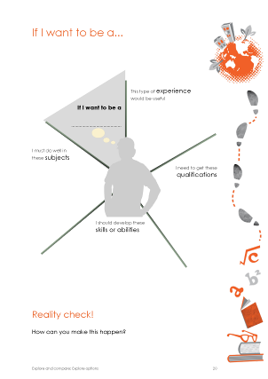
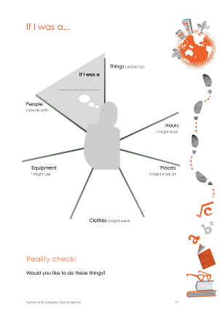
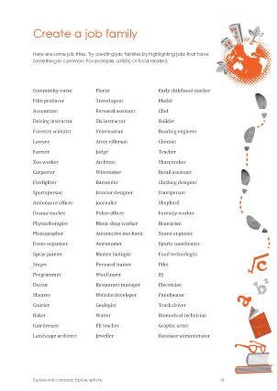
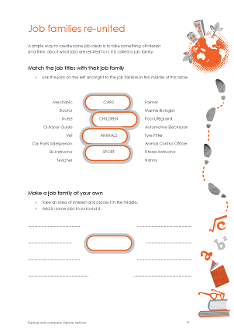
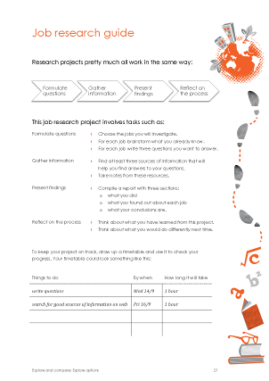
Student worksheets used in this section (continued)

There are four more pages in the Job research guide that follow the page shown.

Setting the scene

Key messages
- Another aspect of learning and career planning is to think about what opportunities exist and how they might develop your interests and strengths.
- Having ideas about some possible future job areas can help you make decisions about what subjects to study and what skills to develop.
- The world of work is experiencing rapid change and you need to be aware of this when thinking about your future.
Possible activities | Possible resources
- Discuss what the 'world of work' means and introduce the idea of change.
- Brainstorm ways to find information about jobs:
  - newspapers, magazines, TV, websites, …

family and friends, watching people work, …
- In groups, students brainstorm example questions they would ask to find out what is involved in a job and what a person needs to be able to do it well. | - Jobs Galore, pg 5,  Research opportunities
- Group the example questions to show the categories of information that are valuable to understanding a job. You could use the structure of the Careers New Zealand jobs descriptions as a starting point. | - [teacher reference] Careers New Zealand website, jobs database

Students identify job interest areas

Key messages
- Job interest areas can help to start you thinking about the kinds of jobs that relate to your interests.
- Job interest areas group jobs by things they have in common, eg, flying.
- If you are interested in one job in an area, it might be useful to check out other jobs in the area, especially if you don't know much about them now.
- If you think your students might find these activities a little difficult, you could begin with some Kiwi Card activities to stimulate their recognition of the different jobs there are in our communities
Possible activities | Possible resources
- Give an overview and demonstration of the concept of job interest areas.  - (optional) Students group jobs they think belong in a job area.  - In groups students each select one of the interests, qualities, skills or values they wrote on their learning and career plan as a title for a job interest area, eg, environment, problem solving, and take it in turns to work with the group to think of all the jobs they can that relate somehow to that. | - Explore and Compare, pg 15, Job families reunited: pg 16, Create a job interest area  - Where To? posters or online tool  - Jobs by Interest brochure or online tool
- The group then selects one of the areas they have created and discusses ways in which the jobs they have suggested may be the same and different to each other.
- Each student then works further on their own job interest area, writing down what they already know about the jobs they listed, what they have found out from family about these or other related jobs (homework), and up to three things they would like to find out more about. | - You could prepare a worksheet for students for this activity
- Each student presents their job interest area as a tree and puts it into a class job forest. When students review the forest they will see jobs can fit into more than one interest area.
- Class discusses which job interest areas in the forest they think may change the most or the least in the future.

Students investigate jobs of interest

Key messages
- The jobs you choose to look at today may not be the jobs you will choose to look at in the future, but they are likely to have some aspects in common, such as the skills you enjoy using.
- Finding out about different jobs is not just about finding something that you might like. It can also help you see what you're not interested in.
Possible activities | Possible resources
- Remind students about the range of information sources about jobs they came up with earlier. Explain that the Careers New Zealand website is a good place to start, because it is comprehensive, independent and up to date.
- (optional) Students use Jobs Galore to find answers to quick questions from you or other students to get an idea of the information they can access on the website. Could be done as a game. | - Jobs Galore
- (optional) Select a job and demonstrate to students how to use the website to find the information they will need in research. | - Careers New Zealand website, jobs database
- Students each choose up to 3 jobs to research.  - If students need help with ideas on what jobs to research they could use the online tools on the Careers New Zealand website to get ideas | - Careers New Zealand website, Subject or Skill matcher, Career Quest
- Students individually research the jobs of their choice.  - This can be done using the Careers New Zealand website only or as a fuller research assignment requiring use of a number of information sources.  - Students can complete a simple worksheet about each job or a longer report on their research approach and conclusions. | - Explore and Compare, pg 19, If I was a… ; pg 20, If I wanted to be a…; pg 21-25, Job research guide  - Careers New Zealand website, jobs database  - Just the Job DVDs, ITO websites, Futureintech website and others
- In pairs, students help each other compare what they have said about themselves – their interests, qualities, skills, values – with what is important in the jobs they have researched, to decide if they really would want to do any of these jobs.

Plan my learning pathway

About this section

Explores factors to consider when making decisions about subjects to study and helps students to align their subject choices to their possible areas of interest.

Prior learning

It is helpful if students have reflected on how they chose this school and their subjects for year 9.

Learning outcomes
Career learning outcomes | Key competencies
Develop and demonstrate skills in decision making.  Demonstrate understanding of learning pathways and skills in choosing senior school subjects.  Demonstrate an understanding of the influence of whānau on career decisions and plans and the importance of support networks. | managing self  thinking

Student worksheets used in this section

There are four other Fact file worksheets that follow this page.

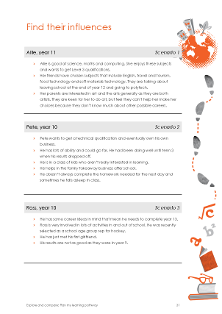
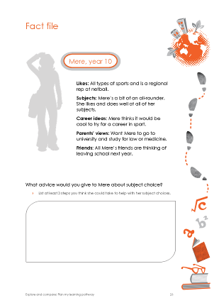
There is one other page in Find their influences that follows this page.
Student worksheets used in this section (continued)

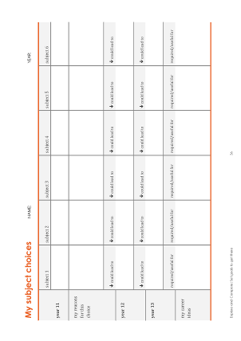
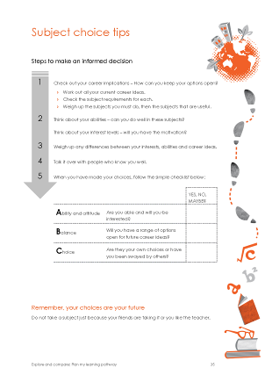
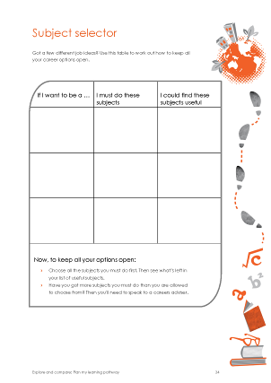
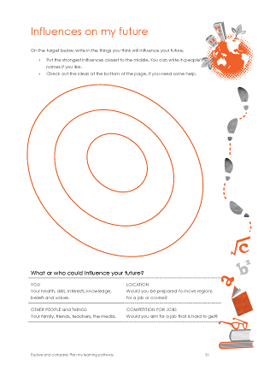
Setting the scene

Key messages
- Choosing subjects is one of the early steps in developing a career direction. It means
making decisions.
- Knowing more about yourself and the opportunities that are available does help you to make better decisions.
- Most people find it helps to talk to others and to get as much information as they can
before deciding.
- There are different ways of making decisions.
Possible activities | Possible resources
- In groups, students recall three examples of day-to-day decisions related to their personal and social lives and how these decisions came about. They group together examples of decisions which were made in a similar way, eg, on the spur of the moment, with help from family.
- Ask each group to report back to the class on the 'styles' of decision-making they have found. Then try to reach agreement on the style(s) they'd recommend for choosing subjects and why.

Students explore decision making

Key messages
- Making decisions about the future can involve a calculated risk. Aim to make the best decision you can, not a perfect one.
- It is important to keep reviewing your decisions and to have a back-up plan in case your choices don't turn out to be available.
- Keep in mind that there may be several ways of achieving a goal.
- Keep your options open as far as possible and always aim to be the best that you can.
Possible activities | Possible resources
- Check the model of decision making used in this activity fits with the models you are using in your school.
- Look at the questions involved in making a major decision when a ‘rational’ or ‘carefully considered’ style of decision-making is used, eg:  - What's my decision about?  - What choices have I got?  - What’s important to me?  - What else do I need to know?  - Who can help me?  - Who can have a say in my decision?  - What are possible consequences of choosing different alternatives?  - What needs to be done, by when, to carry out my decision? | - Jobs Galore, pg 6,  Make a decision
- Use case studies to develop students' understanding of the kinds of decisions they may face in the following years at school. Start by analysing one case study with the students using the questions above. Then give groups each a different case study to analyse and report back on. | - Explore and Compare, pg 26-30, Fact files

Students consider influences on them

Key messages
- We are influenced by the people in our lives and sometimes by people we've been impressed by but never met.
- We can also be influenced by other factors such as where we live, our health or the opportunities that come our way.
- The people who influence you the most are often the people who help and support you the most.
- Influences can be both positive and negative. Understanding how other people’s opinions can affect you can help you to step back from their influence if you want to.
Possible activities | Possible resources
- Ask students to talk about anyone they know who has made a decision that was influenced by something or someone.
- Students look at a list of examples of things that can influence our choices and try to think of others.  - Each student decides who and what might influence their decisions the most and records this in a diagram of concentric circles. The more influential something is the closer it is to the centre of the diagram. | - Explore and Compare, pg 33, Influences on my future
- (optional) Discuss selected career profiles of young people who talk about their influences and how these helped them realise what they needed to do. | - Careers New Zealand website, Digital Careers website, youth magazines, etc
- In groups, students read a scenario and identify the positive and negative influences on the student. They discuss the actions the student could take to reduce the negative influences. | - Explore and Compare, pg 31-32, Influence scenarios  - [teacher reference] In this guide: Using influence scenarios

Students consider subject choices

Key messages
- Choosing subjects is part of a longer process of finding a direction in life.
- It's important to look ahead when you make choices. You won't be able to see what lies ahead but you can start to think about how your choices might be useful in the future.
- Your ideas may change next year or the year after that. Change is normal and expected. It is important to allow for change when you make your choices.
Possible activities | Possible resources
- Students will need the job summary information they recorded in Explore future options.
- Introduce the subject choice process at your school and explain the pathways students can take through senior school, especially in relation to NCEA and UE. | - The school’s subject choice booklet
- (optional) Students read advice on how to choose school subjects and discuss how well prepared they are to make their choices. | - Careers New Zealand website, Choosing school subjects
- Students look at the subject options available to them in the following years at school and identify the subjects their job area investigation suggests they consider studying in the future.  - Provide access to job information if students need to recheck the requirements of jobs of interest. | - Explore and Compare, pg 34, Subject selector  - Careers New Zealand website, jobs database or Jobs Galore
- In pairs, students help each other review the subjects they are considering and write down the pros and cons for choosing each one. | - Explore and Compare, pg 35, Subject choice tips
- Students decide which subjects they should take next year and what they might go on to do later. Work with as many individual students during this time as possible. Involve other staff, mentors, peers and older peers as appropriate. | - Explore and Compare, pg 36, My subject choices
- Ask students to identify subject options they don't understand much about. Organise a time for senior students to come and talk to them about these.
- Students discuss their initial ideas at home with whānau. (Taking a copy of their learning and career plan home would be helpful.)

Set goals to get there

About this section

Introduces goal setting and helps students to set one short-term and one long-term goal that will help them create the future they imagine for themselves.

Prior learning

Students may be used to setting and reviewing learning goals. Depending on students' knowledge and experience, either introduce or quickly review students' understanding of the SMART or SMARTER approach to goal-setting.

Learning outcomes
Career learning outcomes | Key competencies
Demonstrate understanding of short and long-term  career planning.  Demonstrate understanding of the relationship between education achievement and career planning. | managing self  thinking

Student worksheets used in this section

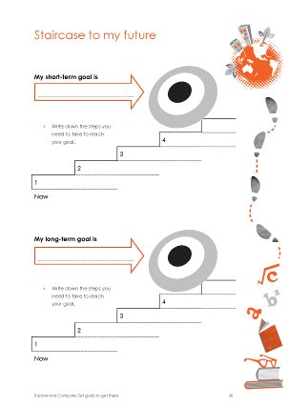
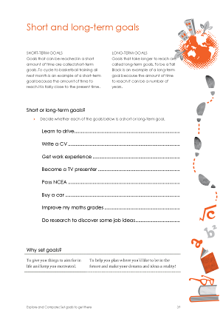
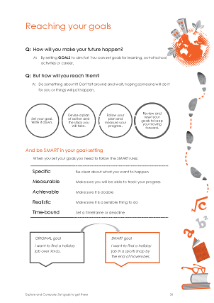
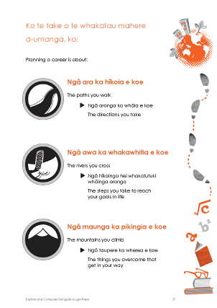
Setting the scene

Key messages
- People with goals get there because they know where they are going. Their goals are their roadmap.
- Having a goal helps you focus and concentrate your time, energy, and resources on what you want. It also helps you to keep going when you strike problems or difficulties.
Possible activities | Possible resources
- Introduce goal setting and planning and its importance in getting us where we want to be.  - Talk with students about setting 'SMART' goals, ie, goals which are specific, measurable, achievable, realistic and time-bound and the importance of evaluating their progress and reviewing their goals regularly (making SMARTER goals).  - Turn some examples of goals into SMART goals. | - Explore and Compare, pg 37, Planning a career is about,  pg 38, Reaching your goals

Students set goals

Key messages
- Writing down a goal and putting a date on it can help you to stick to it.
- Keep reviewing your progress against your goals. If you need to change a date to make it more doable, or change your goal, that's OK.
Possible activities | Possible resources
- Ask students to set themselves one short-term (1-6 months) and one long-term goal (3-5 years) for:  - their school life (learning goals)  - their life outside of school (personal goals)  - their future beyond school (career goals) | - Explore and Compare , pg 39, Short and long-term goals,  pg 40, Staircase to my future  - Jobs Galore, pg 7,  Plan and act
- Help individual students write their goals and discuss with them what kinds of things they will need to do to reach them. Involve other staff, mentors, peers and older peers as appropriate.
- (optional) Students work out and write the steps they will take to reach one short-term and one long-term goal.
- Students write their goals in the My Goals section of the learning and career plan.
- Ask students to recheck their subject choices before the next session.

Students discuss their choices with staff

Key messages
- You will change a great deal over the coming few years so it's best to make choices that don’t shut out other options you might want later on.
- It is OK to change your mind later about what you choose now. And, don't worry about what the 'right' choice is. There are all sorts of different ways to get to what you want to do.
Possible activities | Possible resources
- Students will need the following for these activities:
  - their Learning and career plan

their My subject choices worksheet
- Teachers should have students’ academic records available to them and other relevant information
- Look at the student's plan with them and ask the student to talk you through their exploration and decision process.  - When necessary, discuss any risks or potential problems with their subject choices, eg, timetable, closing off options, and develop solutions. | - The school’s subject choice booklet  - In this guide: Subject choice checklist
- Students write their final subject choices in the My Subject Choices section of the learning and career plan and their comments in My comments.
- Write your comments in the Adviser comments section of the learning and career plan. In your comments include:
  - affirmation on the appropriateness of choices
  - reminders to follow up on goals or choices
  - positive feedback on the research, etc done.
- Students take their completed learning and career plan home to discuss with whānau. The school may want to take a copy before this happens.

Teacher reference

The following were referenced in this guide:

Sample text for letter to parents

Activities for developing careers language

Using influence scenarios

Subject choice checklist

Template letter to parents

date

Dear parent or caregiver

To help your child prepare to choose school subjects for years 11 to 13 and to make choices about what to do after school, we have begun a process called learning and career planning. This process is well-established in career education and can be used at any point in the future to support planning and decision-making about work and life.

At this age, the focus is on developing self-awareness and exploring career possibilities. It is not about your child deciding their future.

Your child will bring their completed learning and career plan home to discuss with you. Parents and caregivers play a big part in supporting their children’s learning and career planning and you can help your child in this process now by:
- asking your child to talk through the things they have identified and affirming these
- discussing any important points you think they might have missed
- being positive about their ideas about the future – seek information and advice from others about these ideas if necessary
- discussing and checking their subject choices, the effect of these choices on later study and training options and their relevance to your child’s career interests.

There is comprehensive information and advice to help you in the Helping young people area of the Careers New Zealand website, www.careers.govt.nz.

Remember that as your child continues through secondary school their ideas and plans will change. Look for further opportunities to explore, discuss, check and support these changes of mind.

Please help us with the next steps in this process by:
- signing and adding your comments to the back page of the plan
- getting this copy of your child’s plan back to us as quickly as possible.

If you have any questions about this process or would like to discuss your child’s ideas with us, please contact … on …

Yours sincerely

xxxxxxxxx

xxxxxxxxxxx

Our learning and career planning process includes:

Know myself

Students explore their interests, qualities, skills, values and achievements and think about how they develop and demonstrate these and how they can be relevant to their future study, training, work and life choices.

Explore future options

Students explore areas of work that interest them, develop skills in locating and using career information, and appreciate what they might need to meet the requirements of particular jobs.

Plan my learning

Students look at ways of making decisions, explore the things that can influence their decisions and develop their skills in setting goals.

Other things you can do to support your child
- Attend school events such as parent evenings and report evenings and take opportunities to discuss your child’s future plans with deans, form teachers, subject teachers, careers advisers, guidance counsellors, etc.
- Go to local careers expos or events to get up-to-date information on a range of study, training and career options.
- Get information from providers of study and training courses.
- Help your child investigate future options. A good place to start is the Choosing school subjects page on the Careers New Zealand website, www.careers.govt.nz

Activity ideas for developing careers language

Round robbin: awareness of terms and definitions

Requires a set of cards which has a definition at the top of the card and a term, but not one matching the definition, at the bottom.

Each student has a card. You can ask students to work in groups or as a class, depending on the number of cards and the amount of time you have.
- To start one person calls out the term on the bottom of their card.
- The rest of the students look at their cards, and the student who has the definition for the term that was called out, says the definition out loud.
- That person then calls out the term they have on the bottom of their card, and the next person says the definition, etc, until you get back to the first person.

You can do this as a repeat activity to reinforce the learning. To do this you need to:
- time the activity to see if you can reduce the time to get through all the terms again.
- shuffle and redistribute the cards after each round.

Compile an A to Z: vocabulary in context

Requires stories about people from newspapers, magazines, websites.

Groups find words or phrases that describe people in the articles. Students could focus on just finding words for qualities, for example, or they could find any words that describe a person’s characteristics and abilities and then categorise them into interests, qualities, skills and values.

The class completes an A-Z list on the board/poster paper/etc.

Positive qualities: applying language

Requires pieces of paper with the name of one student at the top of each. Teachers could add one with their name also.

Hand a piece of paper to each student, but not their own.
- Each person anonymously writes one positive quality of the person on the bottom of the sheet and folds the sheet over to cover what they have written.
- Ask students not to look at what others have written and then ask them to pass their sheet to the person next to them.
- Continue for as many students as you wish.

You can then do one of several things with the sheets depending on your students, for example:
- Choose a few examples and read them out to the class before giving them to the person named on each.
- Distribute the sheets to the person named on each and ask them to look at them in small groups before asking for volunteers to give examples of the qualities written on their sheets.

Using influence scenarios

Instructions

Give groups one scenario each. Ask students to read the scenario and identify:
- who or what is influencing the student
- whether the influences on the person are positive or negative
- possible solutions and/or advice for the person.

Your role is to:
- use questions that prompt discussion to identify influences and help work out solutions.
- make links for students between influences and the possible impact they can have on decision making in these cases and in general
- draw attention to the range of influences there can be on students: other students, friends, family, money, health, stepping outside the family norms and expectations, etc.

Summary of influences present in each scenario

Scenario 1: Allie, year 11
- Allie’s parents appear supportive of further study.
- She is beginning to recognise where her interests and strengths might lie.
- Her friends don’t share her academic aspirations.
- She might be worried that she will disappoint her parents if she doesn’t do art.
- Her parents feel uncertain about how to help her make her choices.

What can Allie do about the situation?
- Research courses and jobs that match her interests.
- Discuss her ideas with the careers adviser or dean and get some help with planning and with discussing her plans with her parents.

Scenario 2: Pete, year 10
- Pete has clear career plans and aspirations.
- He has been achieving well and has the study skills to support achievement.
- At work he is learning skills such as business and customer service.
- His classmates’ behaviour might make him try less.
- Pete’s family’s needs leave him less time to study or to participate in cultural, sporting or other activities.

What can Pete do about the situation?
- Talk to the dean about whether the school can help him to better manage the homework requirements in his subjects.
- The dean might talk to Pete’s parents about his school work and the possibility he may not achieve the results he needs to do what he wants in the future.
- The dean might consider changing him to another class.

Scenario 3: Ross, year 10
- Ross has career ideas and aspirations.
- He likes being active and involved in a variety of things.
- He has too much on his plate.
- He may not be allocating his time well.

What can Ross do about the situation?
- Get some help with time management and study skills.
- Learn to prioritise.

Scenario 4: Ashraf, year 10
- Ashraf is self-motivated.
- He has a boss who is supportive and helpful.
- He demonstrates a responsible attitude towards his schooling and values education.
- He seems to know what is important and what is right and wrong.
- He has friends with different aspirations.
- He may not be allocating his time well enough.

What can Ashraf do about the situation?
- Start thinking about what he wants for his future. Talk to his boss and others about possible directions he could go in.
- Get some help with setting priorities and managing time.

Scenario 5: Pania, year 10
- A supportive uncle and supportive teachers.
- People who have a belief in her.
- She has some long-term goals.
- Concern/pressure about helping with the immediate needs of the family.
- No older brother or sister as a role model.

What can Pania do about the situation?
- Research funding and scholarships: start by checking www.careers.govt.nz which lists the various sources that provide information on this area.
- Discuss her plans with the dean, careers adviser or guidance counsellor and get some help with planning and with discussing her plans with her whānau.

Scenario 6: Naja, year 12
- A supportive family.
- Good academic achievement and lots of options.
- Conflicting ideas about her future direction.
- Tempted to go where her friends are going rather than choose for herself.

What can Naja do about the situation?
- Talk to the careers adviser about opportunities to learn more about tertiary courses that might interest her and find out where they lead to.
- Get a part-time job to get some personal experience of work and earning money.

Subject choice checklist

STUDENT NAME: ………………………………………………….. YEAR: …………
Please use the space under items to write any notes you feel are relevant. |  | DONE?
1 | Filled in subject selection form
2 | Discussed choices with student (use guide on next page)
3 | Checked academic information is accurate
4 | Checked pre-requisites
5 | Checked range and combination of subjects, including meeting UE, literacy and numeracy requirements, keeping options open
6 | Checked workload balance, especially assessment and portfolio load, eg, it is recommended that students take no more than two art subjects
7 | Choices are a good fit with student’s capability (not too hard or easy!)
8 | Choices fit with student’s skills and interests
9 | Choices fit with student’s ideas of future pathways
10 | Choices help meet the pre-requisites for these
11 | Completed student referral if required *  referred to:  reason:
12 | Other useful information:
* Referral is
- recommended when you don’t feel confident that the decision-making process was robust and based on reliable information.
- required when students are considering options like STAR or Gateway.

Year | Appropriate areas of questioning
9, 10 | - What things about this subject made you choose it?  - Who have you talked to about this?  - Where did you get information and advice from?
10, 11 | - What subjects do you currently enjoy most and do best at?  - How hard are you working at your subjects now?  - Have you chosen these subjects for next year? If not, why not?  - Do you currently have any career ideas?  - If so, how do your subject choices fit with these ideas? If not, do you know what career directions your subjects might offer?
Have their subject choices left their options open for the future?
If there is not a science course, is there any good reason why not?
11, 12, 13 | - How well do you think you are going with your Level 1 (or 2) subjects? What are your expectations of achievement?  - How hard have you been working at your subjects?  - Do you know what you need for NCEA Level 1/2/3/UE (as appropriate)?  - Have you spoken with your teachers about doing Level 2 (or 3) in the subject?  - Are you aware of the pre-requisites for the subjects you have chosen?  - Are there any other subjects that you have considered? Have you considered options through STAR, Gateway?  - Are you intending to return for Year 13?  - What job and training ideas do you currently have for beyond school?  - Do you know what the pre-requisites are for these choices beyond school? Do you know what career directions they might offer?  - Have you checked your job and training ideas with someone in that area?
Are their choices realistic?
Should they be doing a full academic programme?
Should they consider a multi-level course?

